March, Alan (from Linked In)

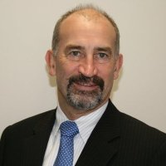

Dickson High School, Canberra, ACT, Bachelor of Science (Forestry) ANU 1975-1979.

Assistant Director General AusAID October 1980 – . Manage disaster and crisis preparedness and response for the Australian government in overseas developing countries. I prepare, deploy and oversight teams of AusAID staff, other government staff and contractors to assist developing countries respond to crises. I also manage and lead partnership with leading United Nations humanitarian organisations and NGOs.

